DB 1: Sales Description

# Create Tables:

* CREATE TABLE Customer(

Cust_ID int NOT NULL,

Cust_Name varchar(30),

PRIMARY KEY(Cust_ID)

);

* CREATE TABLE Item(

Item_ID int NOT NULL,

Item_Name varchar(30),

price int,

PRIMARY KEY(Item_ID)

);

* CREATE TABLE Sales(

Bill_NO int NOT NULL,

Bill_Date Date,

Quantity_Sold int,

PRIMARY KEY(Bill_NO)

);

* CREATE TABLE Relationship_R_I(

Cust_ID int NOT NULL,

Item_ID int NOT NULL,

Bill_NO int NOT NULL

);

# 

# 

# 

# Insert Values:

* INSERT INTO customer VALUES

(1, 'NAim'),

(2, 'Antor'),

(3, 'Sohan'),

(4, 'Yeasir'),

(5, 'Abid'),

(6, 'Soumik'),

(7, 'Fariz'),

(8, 'Sadaf'),

(9, 'Jion'),

(10, 'Asif');

* INSERT INTO item VALUES

(1, 'Jersey', 1000),

(2, 'Trouser', 1500),

(3, 'Boot', 2000),

(4, 'Sock', 100),

(5, 'Guards', 300),

(6, 'Football', 400),

(7, 'Shorts', 200),

(8, 'Goalposts', 3000),

(9, 'Corner Flags', 1500),

(10, 'Whistle', 100);

* INSERT INTO sales VALUES

(1, '2021-07-01', 5),

(2, '2021-07-02', 5),

(3, '2021-07-03', 10),

(4, '2021-07-04', 10),

(5, '2021-07-05', 5),

(6, '2021-07-06', 15),

(7, '2021-07-07', 10),

(8, '2021-07-08', 5),

(9, '2021-07-09', 5),

(10, '2021-07-10', 10),

(11, '2021-07-11', 5),

(12, '2021-07-12', 5),

(13, '2021-07-13', 5),

(14, '2021-07-14', 10),

(15, '2021-07-15', 5),

(16, '2021-07-16', 5),

(17, '2021-07-17', 5),

(18, '2021-07-18', 5),

(19, '2021-07-19', 5),

(20, '2021-07-20', 10),

(21, '2021-07-21', 5),

(22, '2021-07-22', 5),

(23, '2021-07-23', 5),

(24, '2021-07-24', 5),

(25, '2021-07-25', 5),

(26, '2021-07-26', 10),

(27, '2021-07-27', 5),

(28, '2021-07-28', 5),

(29, '2021-07-29', 5),

(30, '2021-07-30', 10),

(31, '2021-07-31', 5);

* INSERT INTO relationship_r_i VALUES

(1, 3, 5),

(2, 4, 6),

(3, 5, 7),

(4, 6, 8),

(5, 7, 9),

(6, 8, 10),

(7, 9, 11),

(8, 10, 12),

(1, 1, 1),

(2, 2, 2),

(3, 3, 3),

(4, 4, 4),

(5, 5, 5),

(6, 6, 6),

(7, 1, 15),

(8, 2, 16),

(9, 3, 17),

(10, 4, 18),

(1, 5, 19),

(2, 6, 20),

(3, 7, 21),

(4, 8, 22),

(5, 8, 23),

(6, 9, 24),

(7, 7, 25),

(8, 8, 26),

(9, 9, 27),

(10, 10, 28), (10, 10, 29), (10, 10, 30), (3, 5, 31);

# Queries:

### **iii. Give a count of how many items have been purchased by each customer in different bill number:**

SELECT Bill_NO, Cust_ID, Cust_Name, COUNT(Item_ID) as Num_Of_Items

FROM customer

NATURAL JOIN relationship_r_i NATURAL JOIN item NATURAL JOIN sales

GROUP BY(Bill_NO)

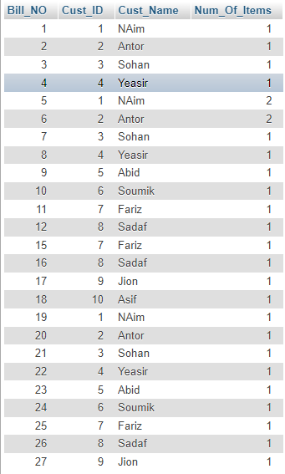

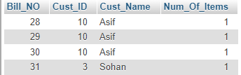

### **iv. List the total bill amount with the quantity sold, total price of the items:**

SELECT Item_ID, Item_Name, price, Quantity_Sold, (price * Quantity_Sold) as Total_Amount, Bill_Date

FROM item

NATURAL JOIN relationship_r_i NATURAL JOIN sales

ORDER BY Item_ID, Bill_Date

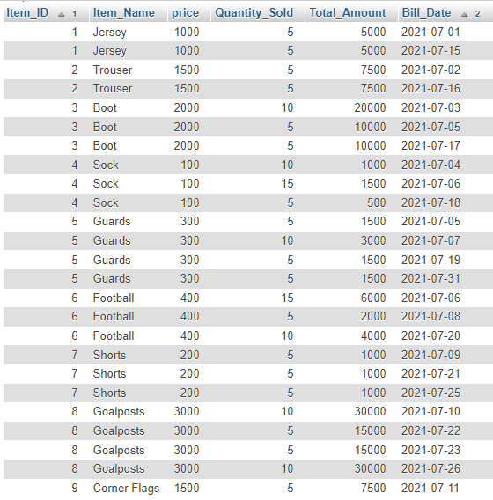

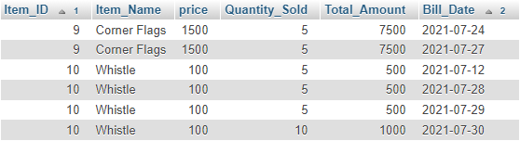

### **v. Determine the total sold of a particular item in the month July 2021:**

SELECT Item_ID, Item_Name, price, SUM(Quantity_Sold) as Total_Sold, SUM((price * Quantity_Sold)) as Total_Amount

FROM item

NATURAL JOIN relationship_r_i NATURAL JOIN sales

WHERE Bill_Date LIKE '2021-07-__'

GROUP BY Item_ID

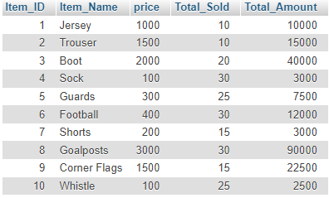

### **vi. Produce 20% less bill for a customer who have bill more than BDT3000:**

SELECT Bill_Date, Cust_ID, Cust_Name, Item_Name, price, Quantity_Sold AS Bought, (price * Quantity_Sold) AS Total_Bill,

CASE

WHEN (price * Quantity_Sold) > 3000 THEN (SELECT (price * Quantity_Sold) - ((price * Quantity_Sold)* 0.20))

ELSE (price * Quantity_Sold)

END AS Disount_Bill

FROM customer

NATURAL JOIN relationship_r_i

NATURAL JOIN item

NATURAL JOIN sales

ORDER BY Bill_Date

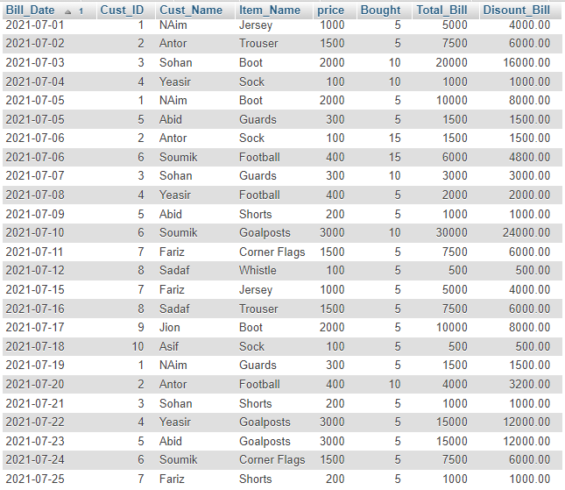

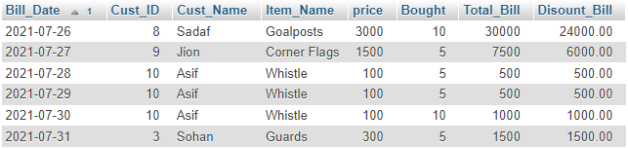

DB 2: Design Tour

# Create Tables:

* CREATE TABLE Bus(

Bus_NO int(5) NOT NULL,

Source_Place varchar(20),

Destination varchar(20),

Couch_Type varchar(10),

Fair int(4),

PRIMARY KEY(Bus_NO)

);

* CREATE TABLE Reservation(

Pnr_NO int(9) NOT NULL,

No_Of_Seats int(8),

Address varchar(50),

Contact_NO int(10),

Status_IS char(3),

PRIMARY KEY(Pnr_NO)

);

* CREATE TABLE Ticket(

Ticket_NO int(9) NOT NULL,

Age int(4),

Sex char(4) NOT NULL,

Source_Place varchar(20),

Destination varchar(20),

Dep_Time varchar(4),

Journey_Date Date,

PRIMARY KEY(Ticket_NO)

);

* CREATE TABLE Passenger(

Ticket_NO int(9) NOT NULL,

Name varchar(40),

Age int(4),

Sex char(4) NOT NULL,

Contact_NO int(10),

PRIMARY KEY(Contact_NO),

FOREIGN KEY(Ticket_NO) REFERENCES Ticket(Ticket_NO)

);

* CREATE TABLE Cancellation(

Pnr_NO int(9) NOT NULL,

No_Of_Seats int(8),

Address varchar(50),

Contact_NO int(10),

Status_IS char(3),

FOREIGN KEY(Pnr_NO) REFERENCES Reservation(Pnr_NO),

FOREIGN KEY(Contact_NO) REFERENCES Passenger(Contact_NO)

);

# Insert Values:

* INSERT INTO bus VALUES

(1, 'Rajshahi', 'Dhaka', 'AC', 1050),

(2, 'Rajshahi', 'Khulna', 'AC', 1050),

(3, 'Rajshahi', 'Chattogram', 'AC', 2100),

(4, 'Rajshahi', 'Sylhet', 'AC', 1500),

(5, 'Rajshahi', 'Natore', 'AC', 100),

(6, 'Rajshahi', 'Sirajgonj', 'AC', 500),

(7, 'Rajshahi', 'Pabna', 'AC', 300),

(8, 'Rajshahi', 'Chapai', 'AC', 200),

(9, 'Rajshahi', 'Noagaon', 'AC', 400),

(10, 'Rajshahi', 'Bogura', 'AC', 600),

(11, 'Rajshahi', 'Dhaka', 'Non AC', 750),

(12, 'Rajshahi', 'Khulna', 'Non AC', 750),

(13, 'Rajshahi', 'Chattogram', 'Non AC', 1500),

(14, 'Rajshahi', 'Sylhet', 'Non AC', 1200),

(15, 'Rajshahi', 'Natore', 'Non AC', 80),

(16, 'Rajshahi', 'Sirajgonj', 'Non AC', 350),

(17, 'Rajshahi', 'Pabna', 'Non AC', 200),

(18, 'Rajshahi', 'Chapai', 'Non AC', 150),

(19, 'Rajshahi', 'Noagaon', 'Non AC', 250),

(20, 'Rajshahi', 'Bogura', 'Non AC', 400),

(21, 'Dhaka', 'Rajshahi', 'AC', 1050),

(22, 'Rajshahi', 'Dhaka', 'AC', 1000),

(23, 'Chattogram', 'Dhaka', 'AC', 1000),

(24, 'Dhaka', 'Chattogram', 'Non AC', 750),

(25, 'Chattogram', 'Dhaka', 'Non AC', 750);

* INSERT INTO reservation VALUES

(1000001, 3, 'Seroil, Rajshahi', 1738663624, 'YES'),

(1000002, 4, 'Dargapara, Rajshahi', 1738663123, 'YES'),

(1000003, 5, 'Dhanmondi, Dhaka', 1738663456, 'YES'),

(1000004, 6, 'Machuyapara, Rajshahi', 1738663789, 'YES'),

(1000005, 2, 'Khulipara, Rajshahi', 1738661234, 'YES'),

(1000006, 1, 'Sobjipara, Rajshahi', 1738665678, 'YES'),

(1000007, 9, 'Padma Abashik, Rajshahi', 1738612345, 'YES'),

(1000008, 10, 'Reshom Potti, Rajshahi', 1738678912, 'YES');

* INSERT INTO ticket VALUES

(1, 18, 'M', 'Dhaka', 'Rajshahi', '1200', '2021-07-01'),

(2, 14, 'M', 'Rajshahi', 'Dhaka', '1200', '2021-07-01'),

(3, 12, 'F', 'Rajshahi', 'Dhaka', '1200', '2021-07-01'),

(4, 13, 'M', 'Rajshahi', 'Dhaka', '1200', '2021-07-01'),

(5, 15, 'M', 'Dhaka', 'Rajshahi', '0100', '2021-07-01'),

(6, 16, 'M', 'Dhaka', 'Chattogram', '1200', '2021-07-02'),

(7, 18, 'M', 'Rajshahi', 'Chattogram', '1200', '2021-07-03'),

(8, 19, 'M', 'Rajshahi', 'Dhaka', '0100', '2021-07-04'),

(9, 20, 'M', 'Rajshahi', 'Noagaon', '0100', '2021-07-05'),

(10, 40, 'M', 'Dhaka', 'Rajshahi', '1200', '2021-07-06');

* INSERT INTO passenger VALUES

(1, 'NAim', 18, 'M', 1738663624),

(2, 'Antor', 14, 'M', 1738663123),

(3, 'Susmita', 12, 'F', 1738663456),

(4, 'Sohan', 13, 'M', 1738663789),

(5, 'Yeasir', 15, 'M', 1738661234),

(6, 'Abid', '16', 'M', 1738665678),

(7, 'Jion', '18', 'M', 1738612345),

(8, 'Soumik', '19', 'M', 1738678912);

* INSERT INTO cancellation VALUES

(1000005, 2, 'Khulipara, Rajshahi', 1738661234, 'YES'),

(1000006, 1, 'Sobjipara, Rajshahi', 1738665678, 'YES'),

(1000007, 9, 'Padma Abashik, Rajshahi', 1738612345, 'YES'),

(1000008, 10, 'Reshom Potti, Rajshahi', 1738678912, 'YES');

* INSERT INTO bus_tic VALUES

(1, 8),

(22, 2),

(22, 3),

(22, 4),

(21, 1),

(21, 5),

(21, 10),

(19, 9);

* INSERT INTO bus_pnr VALUES

(1, 1000001),

(22, 1000002),

(22, 1000003),

(22, 1000004),

(21, 1000005),

(21, 1000006),

(21, 1000007),

(19, 1000008);

# Queries:

### **1.** **How many passengers booked tickets for bus no 22 which is scheduled to run from Rajshahi to Dhaka on 1st of July 21, at 12:00PM:**

SELECT Sum(No_OF_Seats) AS Total_Ticket_Booked FROM reservation

NATURAL JOIN bus_pnr

NATURAL JOIN bus

NATURAL JOIN bus_tic

NATURAL JOIN ticket

WHERE Bus_NO = 22 AND Source_Place = 'Rajshahi' AND Destination = 'Dhaka' AND Journey_Date = '2021-07-01' AND Dep_Time = '1200'



### **2. How many tickets have been canceled in the month of July 2021:**

SELECT COUNT(Ticket_NO) AS Cancelled_Tickets FROM cancellation

NATURAL JOIN bus_pnr

NATURAL JOIN bus_tic

NATURAL JOIN ticket

WHERE Journey_Date LIKE '2021-07-__'



### **3. List the details of the customer who are travelling under age of 18 in bus no 22 on 1st July 2021 at 12:00 PM:**

SELECT Name, Sex, Age, Contact_NO FROM passenger

NATURAL JOIN ticket

NATURAL JOIN bus_tic

NATURAL JOIN bus

WHERE Bus_NO = 22 AND Journey_Date = '2021-07-01' AND Dep_Time = '1200' AND Age < 18

